Testing: Original_Image, Recinstruction_Image

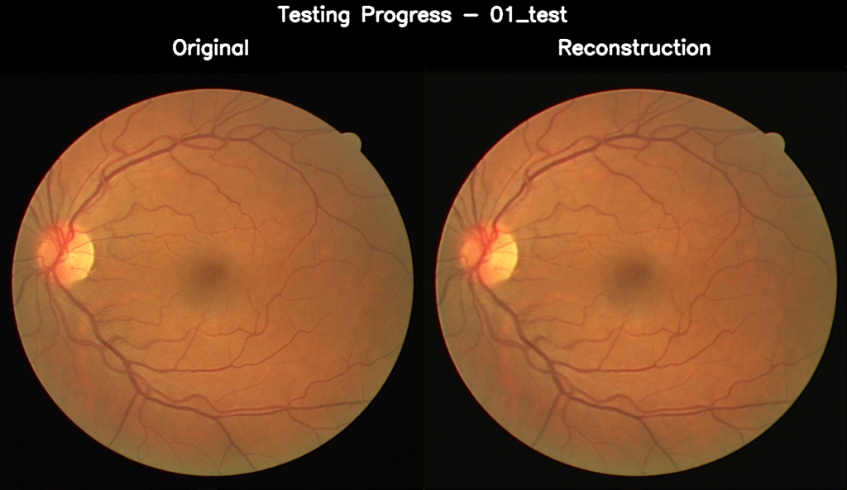

01_test.png, PSNR: 40.25 dB

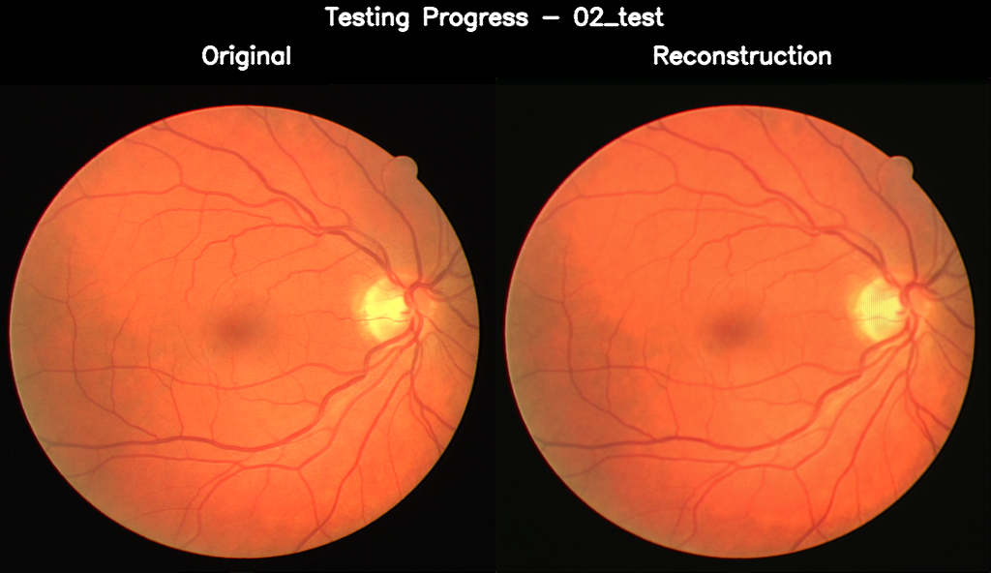

02_test.png, PSNR: 37.74 dB

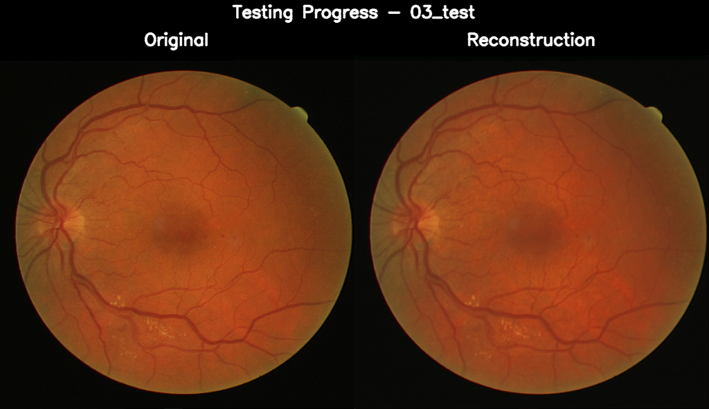

03_test.png, PSNR: 36.56 dB

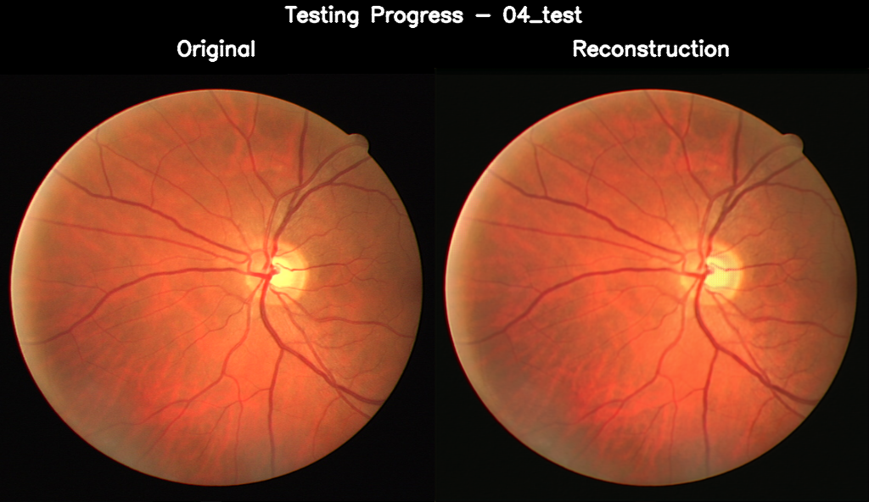

04_test.png, PSNR: 37.87 dB

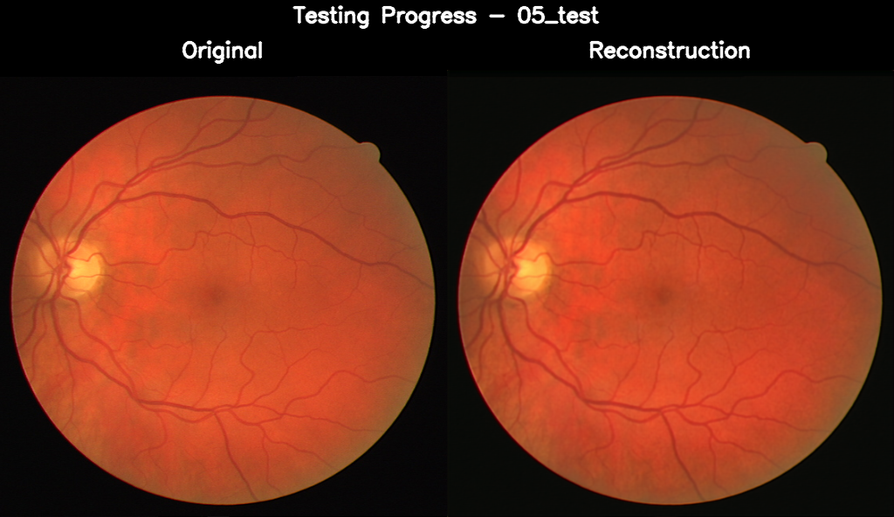

05_test.png, PSNR: 36.68 dB

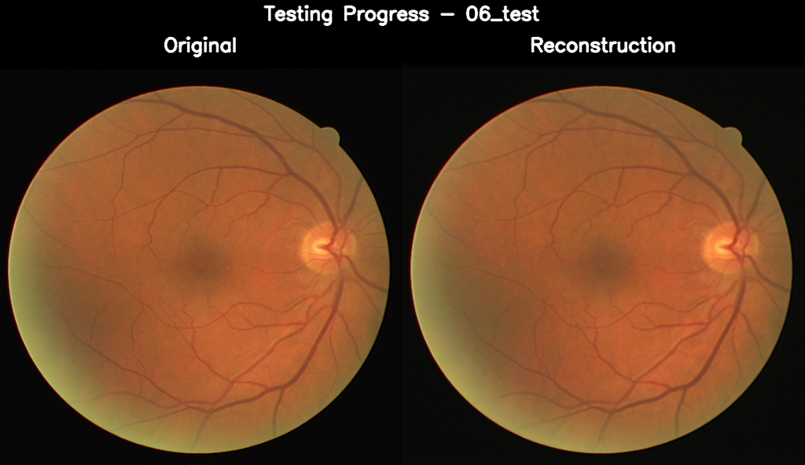

06_test.png, PSNR: 39.25 dB

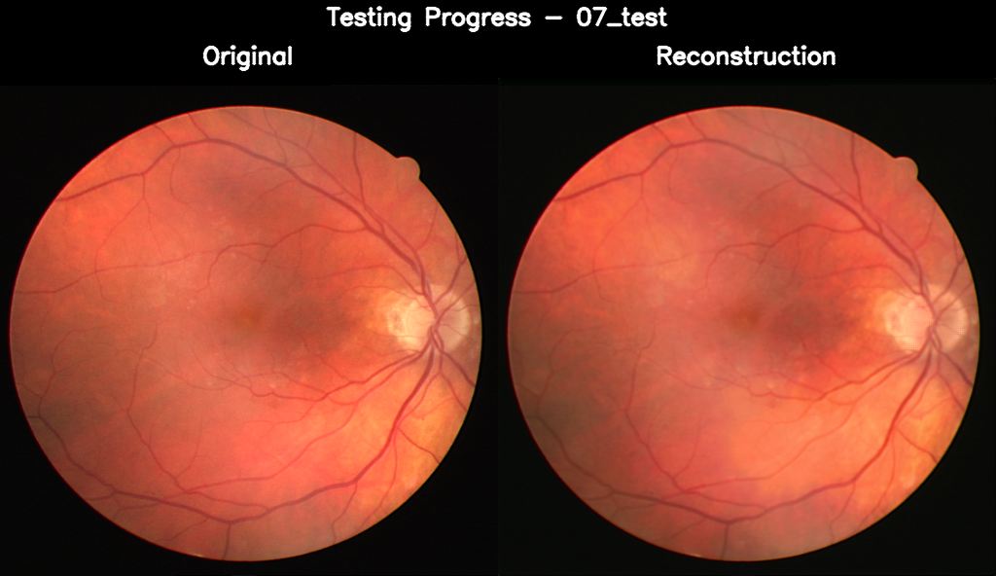

07_test.png, PSNR: 37.43 dB

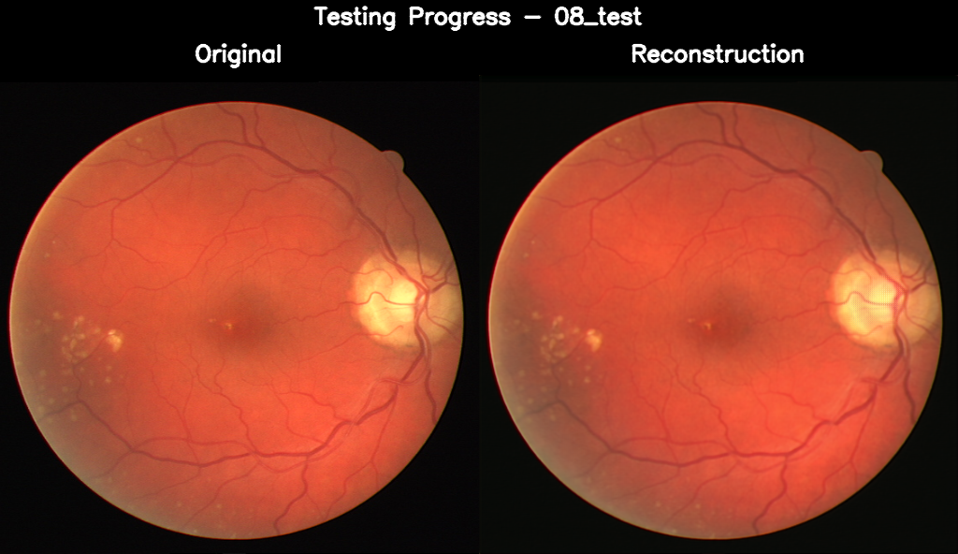

08_test.png, PSNR: 38.75 dB

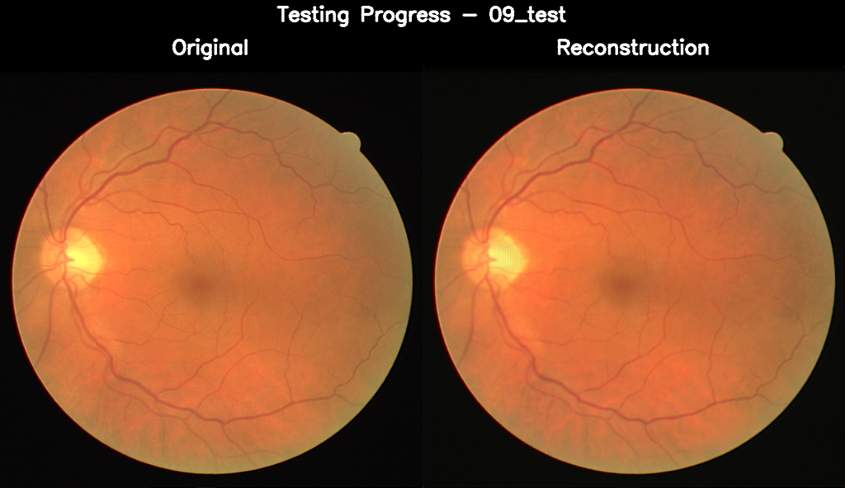

09_test.png, PSNR: 39.51 dB

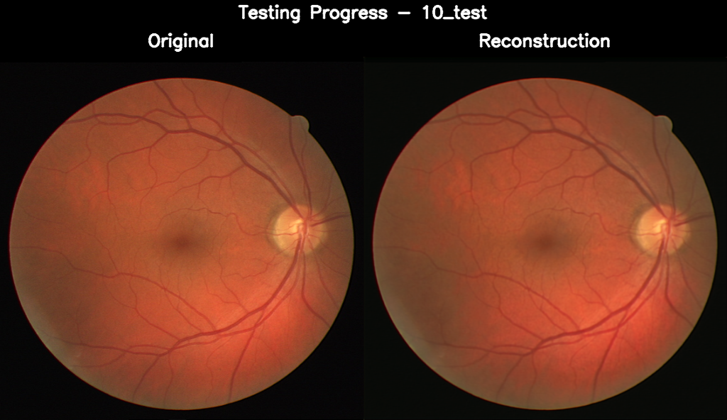

10_test.png, PSNR: 37.91 dB

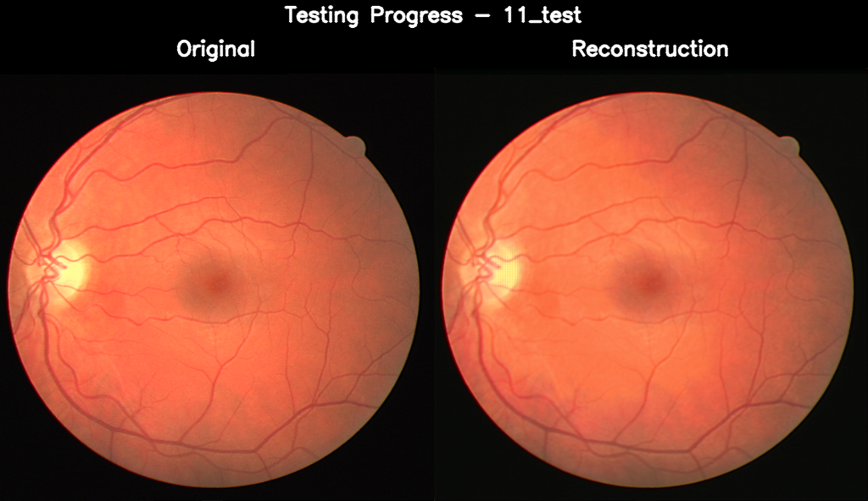

11_test.png, PSNR: 37.03 dB

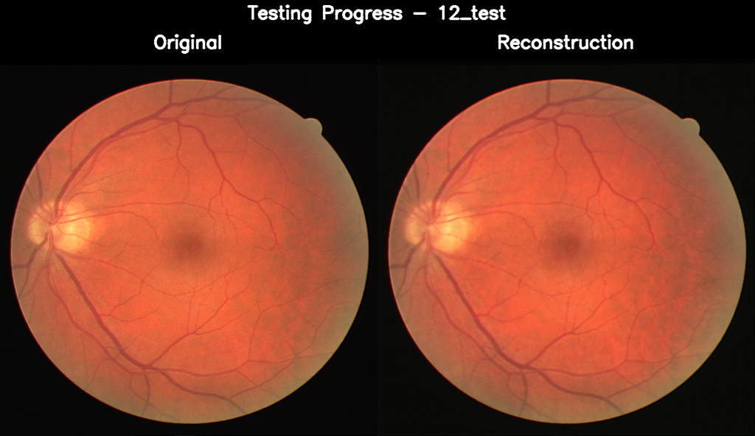

12_test.png, PSNR: 39.11 dB

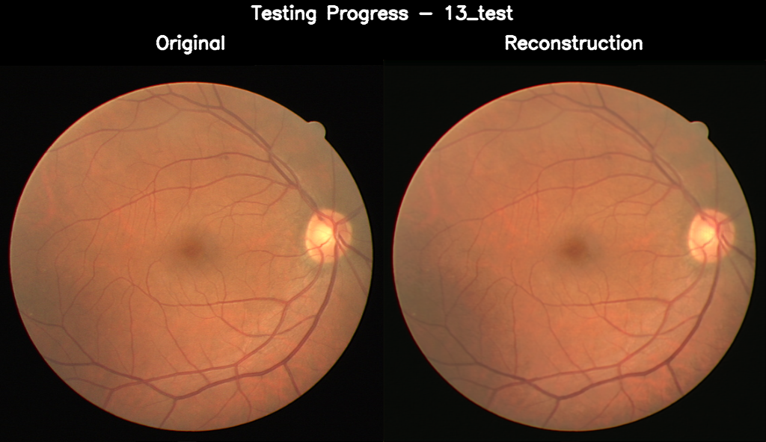

13_test.png, PSNR: 39.15 dB

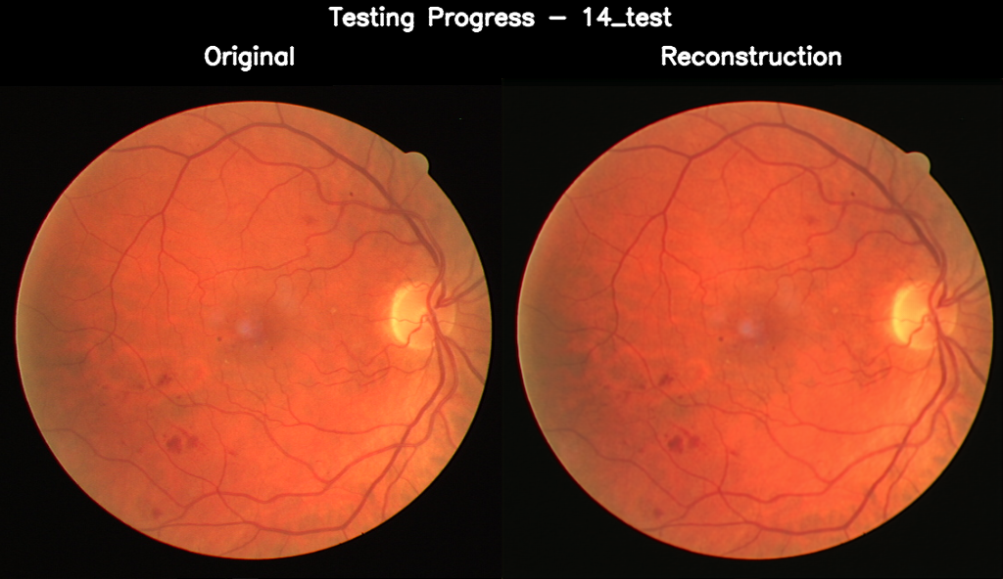

14_test.png, PSNR: 38.41 dB

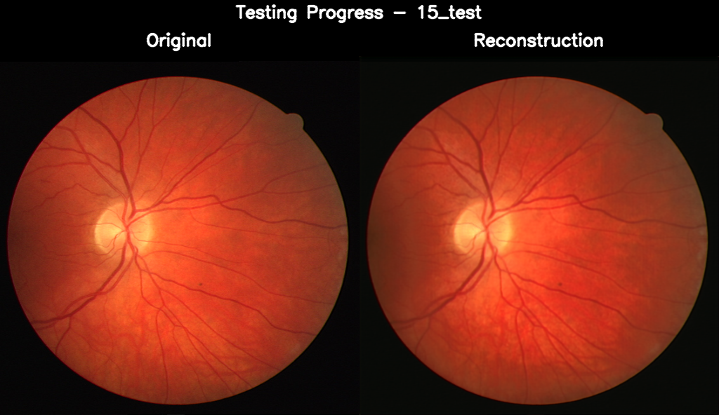

15_test.png, PSNR: 35.16 dB

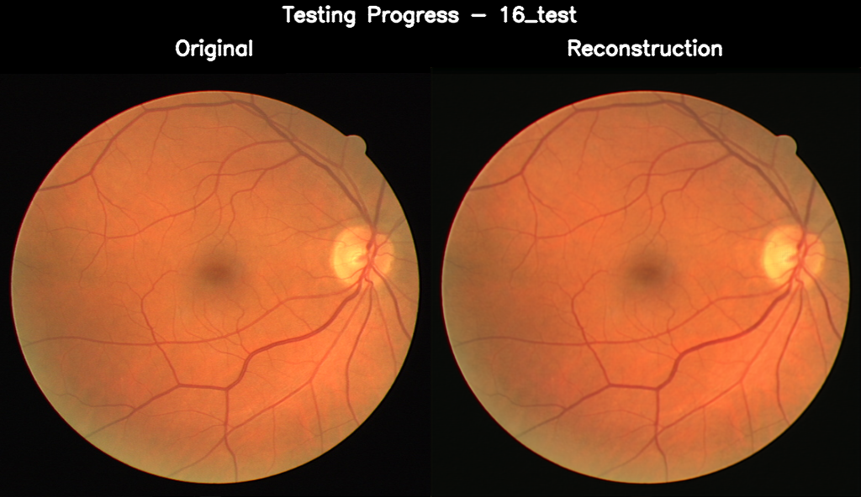

16_test.png, PSNR: 39.18 dB

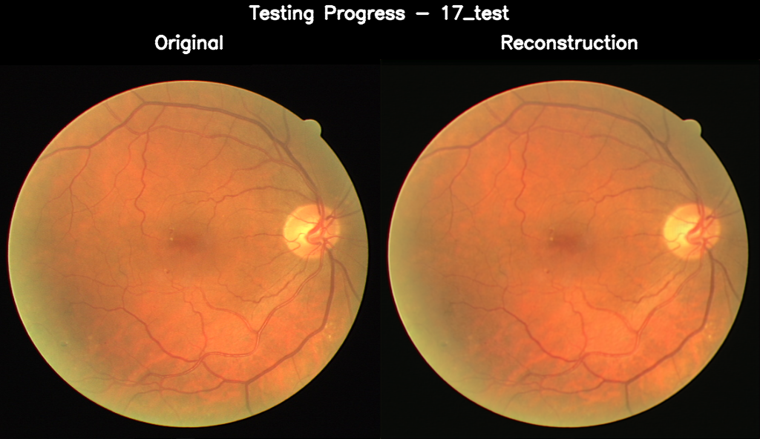

17_test.png, PSNR: 38.46 dB

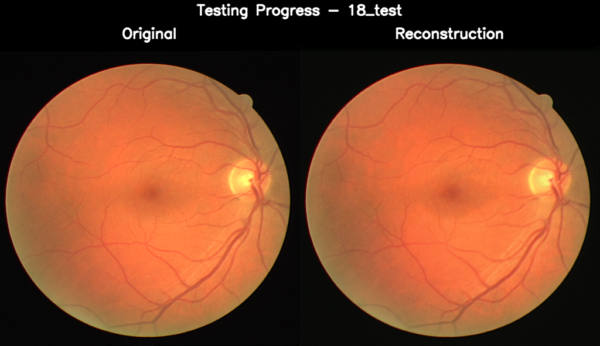

18_test.png, PSNR: 38.91 dB

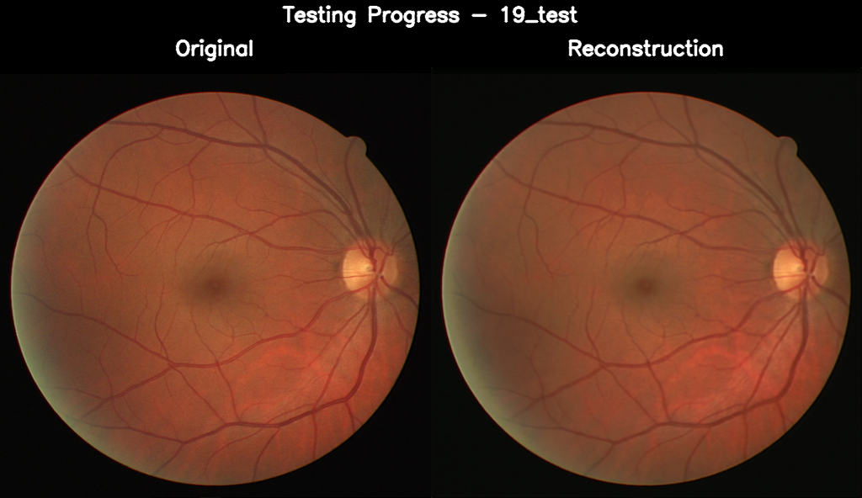

19_test.png, PSNR: 37.49 dB

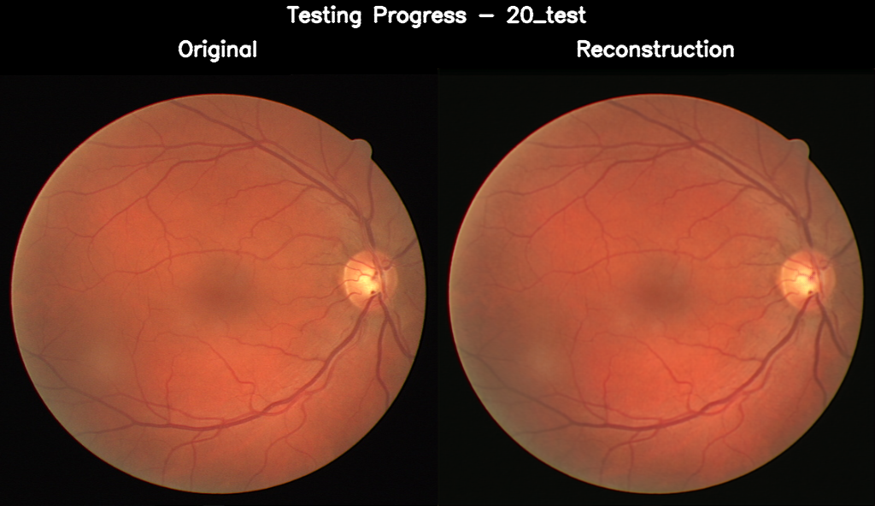

20_test.png, PSNR: 39.57 dB

Training Details:

Epochs: 200

w/o augmentation and validation set

Loss_Curve:

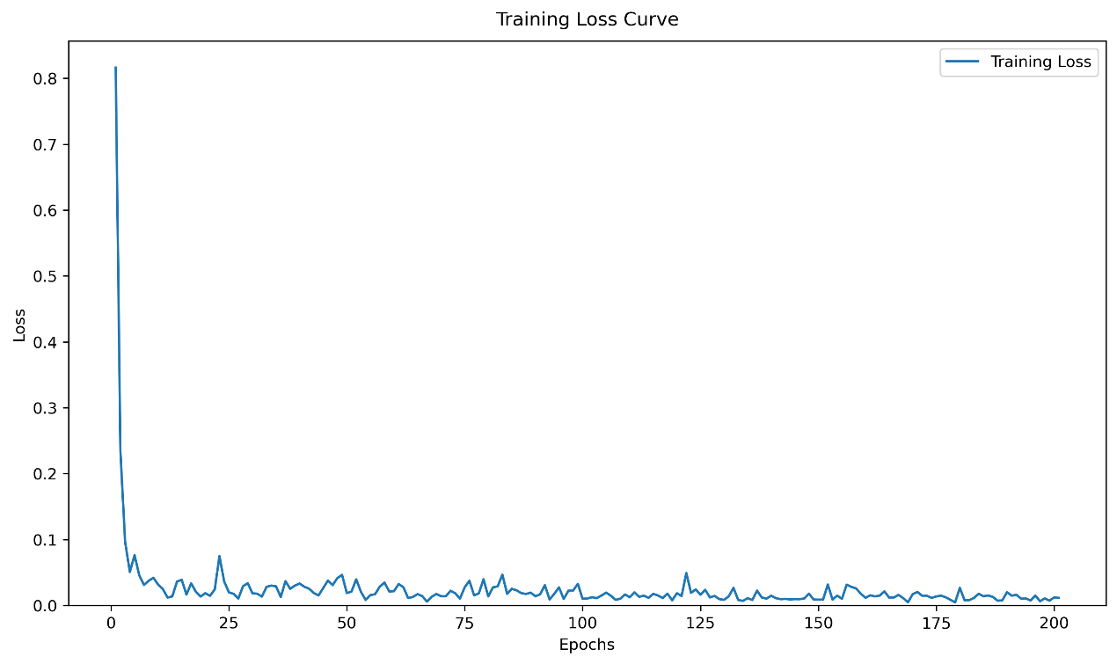

Table of Metrics：





